**Data Structure**

**Quiz - 1**

**Section SE3A**  
Time Allowed: 30 Minutes

Question

Write a function detectAndRemoveLoop() that checks whether a given Linked List contains a loop and if the loop is present then removes the loop and returns true. If the list doesn’t contain a loop then it returns false. The below diagram shows a linked list with a loop. detectAndRemoveLoop() must change the below list to 1->2->3->4->5->NULL.

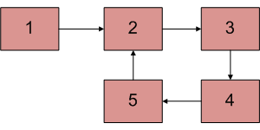

List Code:

#include <iostream>

using namespace std;

template <typename T>

class list

{

public:

class node {

T data;

node* next;

node(T data, node* p) { this->data = data; next = p; }

friend class list<T>;

};

//Other Functions of Link list

void printList();

void InsertatTail(T value);

list() { head = nullptr; tail = nullptr; }

~list();

private:

node* head;

node* tail;

};

//Destructor

template <typename T>

list<T>::~list()

{

node* temp;

while (head != nullptr)

{

temp = head;

head = head->next;

delete temp;

}

}

//print list

template <typename T>

void list<T>::printList()

{

node* current;

current = head;

while (current != nullptr)

{

cout << current->data << " -> ";

current = current->next;

}

cout << "NULL" << endl;

}

//insertnode at tail

template <typename T>

void list<T>::InsertatTail(T value)

{

node* nnode = new node(value, nullptr);

if (head == nullptr)

{

head = nnode;

tail = nnode;

}

else {

tail->next = nnode;

tail = nnode;

}

}